LAB SHEET


K.R. MANGALAM UNIVERSITY SOET
(School of Engineering & Technology) B.TECH CSE (CORE)
Database & Management System Lab (ENCS254)

Submitted by- Submitted to-
Jony Gautam Mansi Kajal
Roll no - 2401010032

LAB SEET – 2

Objective: To understand and implement SQL transactions using COMMIT, SAVEPOINT, and ROLLBACK, retrieve records using SELECT queries, and perform INSERT, UPDATE, and ALTER operations on tables.

DDL Questions (Data Definition Language)
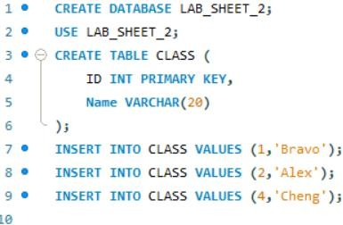
- Create table CLASS

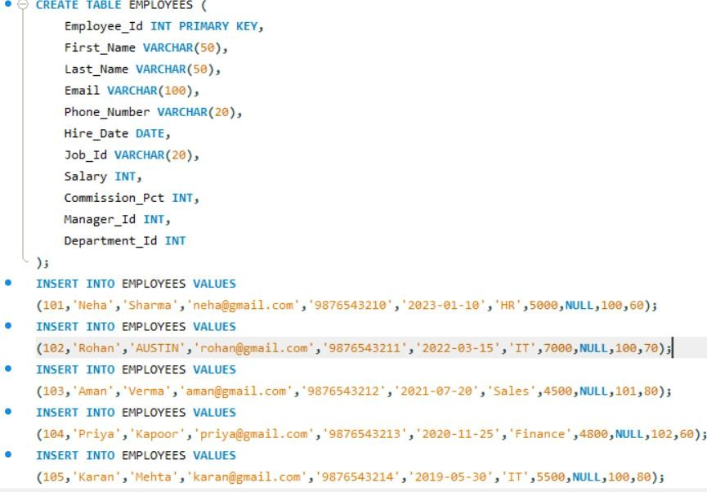
- Create table EMPLOYEES
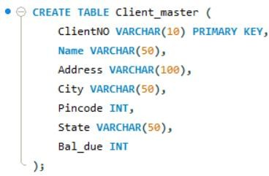
- Create table Client_master
- Rename table Client_master to Client12
- Display bal_due column heading as “BALANCE”


DML Questions (Data Manipulation Language)
- Part A: Transactions and Savepoints (CLASS Table)

- COMMIT

- SAVEPOINT A

- SAVEPOINT B
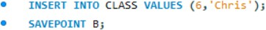
- SAVEPOINT C


- SELECT ALL FROM CLASS
Output:
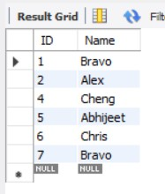

- ROLLBACK TO B AND SELECT ALL FROM CLASS


Output:
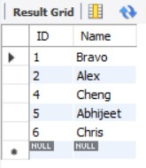
- ROLLBACK TO A AND SELECT ALL FROM CLASS


Output:
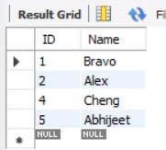

Part B: Retrieving Records (EMPLOYEES Table)

- Employee id, names and salaries
OUTPUT:
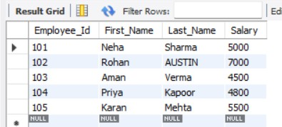

- Employees under manager 100
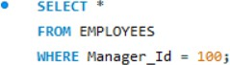

Output:
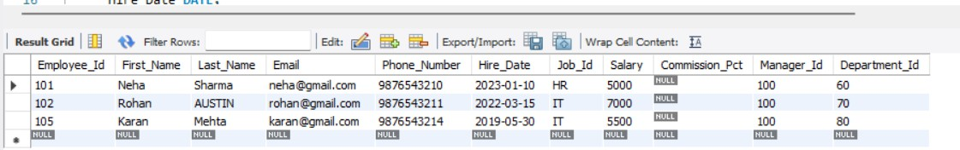

- Salary ≥ 4800
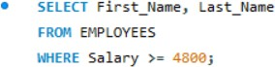

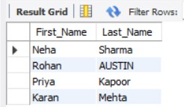
Output:

- Last name = 'AUSTIN'
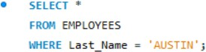
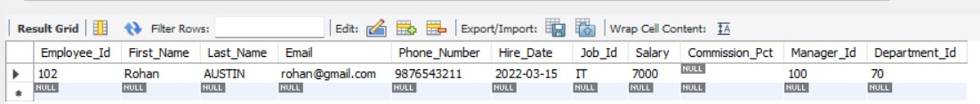
- Department 60, 70, 80
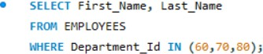

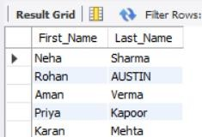
Output:

- Display unique Manager_Id
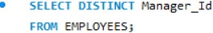
Output:
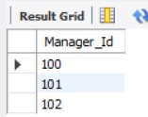

Part C: Updating Records (Client_master Table)
- Insert 5 records
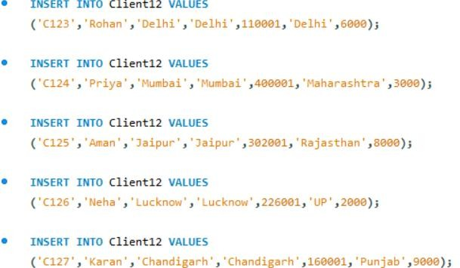
- Clients with bal_due > 5000
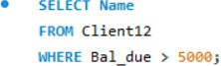

Output:
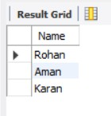
- Change bal_due of ClientNO "C123" to 5100
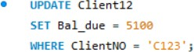

Output:
